Spatial Analysis and Geospatial Analysis   
Data Science in Python



**Anish Mahapatra**

Contents

Introduction 4

What is Geospatial Data? 4

How to work with spatial data in python? 5

The Adoption of Python in GIS 8

Desktop and Interactive computational geospatial programming Applications of Python in GIS 8

The Basics 10

Text 10

Vector 10

Raster 11

Coordinate Reference System (CRS) 11

Map Projections 11

Georeferencing 12

Geocoding 12

Python Geo-spatial libraries 13

What can you put into geometry? 13

Loading data 13

CRS 13

Visualization 13

Reading in data 13

Plotting the outbreak 13

How Jupyter Notebook is used in GIS 13

Conclusion 14

Frequently Asked Questions (FAQs) 14

Is Python or R better for spatial analysis? 14

How do you do geospatial analysis in Python? 15

What are the 5 concepts of spatial analysis? 15

What is spatial analysis method? 15

What is spatial analysis used for? 15

Author 16

# Introduction

Spatial data is any form of data that helps us directly or indirectly reference a specific location or geographical area either on the surface of the earth or elsewhere. Geographic Information systems or GIS in short is the most common method of processing and analyzing spatial data. This includes the entire stack of data management, manipulation, customization, visualization and analysis of the spatial data. GIS are a combination of programs working together aiding users to understand make sense of the spatial data.

For example, if you were to work with GIS data for any project pertaining with spatial data within your geographical area, you will be dealing with different types of data such as vector data (lines - street data), polygons (boundaries of a geographic area) and point locations (buildings, skyscrapers, schools, etc.). These dataset would each exist as a layer of its own in GIS where placement of these layers become crucial for your understanding and analysis

The applications of GIS field and study extends much further than digital mapping and cartography, consisting of multitude of categories such as remote sensing, spatial analysis and geovisualization. Here, in each of these applications the spatial data becomes much more complex to use.

With this article, we shall tap into the understanding of spatial data and geospatial data analysis with python through some examples and also how to perform operations from spatial statistics python libraries. We shall also go through a few basics and pre-requisites that will be necessary for understanding spatial data, with how python for spatial analysis has taken a center stage in today’s world for application of GIS. Jupyter Notebook’s relevance is also included that allows us to work with two of the most popular software for GIS which are ArcGIS (Online cloud-based mapping and analysis solution) and QGIS (Quantum Geographic Information System, a free open-source GIS software with many free online resources and maps available to download) for spatial data analysis with python.

# What is Geospatial Data?

Let us try first to understand what geospatial data is and look at a few examples. Geospatial data is information about describing objects, events, and other features with a location on or near the earth’s surface. The geospatial data combines the information about the location which typically consists of the coordinates of the earth and also the attribute information which talks about the characteristics, events, or phenomena regarding the objects along with its temporal information which is the life span or time at which the attributes and location exist. It typically consists of large datasets of spatial data obtained from multiple sources in different formats, including telephone data, satellite imagery, weather data, etc.

Much of the geospatial data that is available is open source (freely accessible to users) cause it consists of data that can reference roads, localities, water bodies, and public amenities which are of general interest to a wide range of users and is helpful for a number of purposes to both public and private organizations. This open-source data is mainly made accessible through open standards which are heavily supported within the geospatial community. This is due to the fact that primarily, a large number of agencies both locally and globally are involved in the generation of geospatial data, and secondarily because of the wide range of applications.

Geospatial analytics is used mainly to add timing and location to traditional data. Maps, graphs, statistics, and cartograms that depict recent and historical developments can be included in these visualizations. This added background enables a fuller understanding of the events. Easy-to-identify visual patterns and graphics are used to convey insights that might be missed in a large spreadsheet.

In the next section, we will be looking at performing geospatial data analysis in python that employs python spatial analysis library

# How to work with spatial data in python?

Now that we have understood what spatial/geospatial data looks like, we shall now look into a few exercises which will introduce us to how to use python for geospatial data analysis. We shall start if with showing a few basic functions within the GeoPy library from python which uses third-party geocoders and other data sources to quickly find the coordinates of addresses, cities, nations, and landmarks all around the world. Each geolocation service that we use such as Google Maps, Bing Maps, etc. have their own class in geopy.geocoders which abstracts the service API.

**Exercise 1**: Let’s simply begin with checking if we can get the coordinates by entering the name of a popular place and vice versa. Here we shall be using the Taj Mahal as a reference for our exercise. This example will serve as an introduction to working with coordinates and locations around the world.

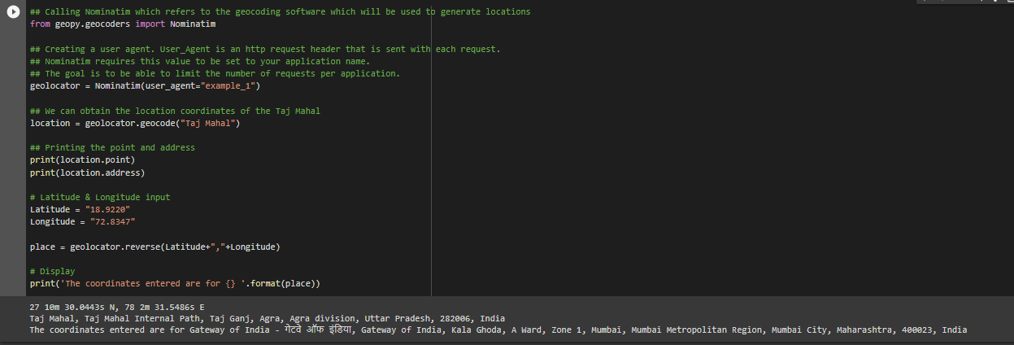

**Exercise 2**: Here, we shall locate the Gateway of India on the map. For doing this we shall be using the folium. Folium draws on the data manipulation and mapping prowess of the Python ecosystem and the leaflet.js package. The package makes it easier to visualize data that has been manipulated in Python on an interactive leaflet (Leading open-source JS library for mobile-friendly interactive maps) map. It enables both the binding of data to a map for choropleth visualizations as well as passing rich vector/raster/HTML visualizations as markers on the map.

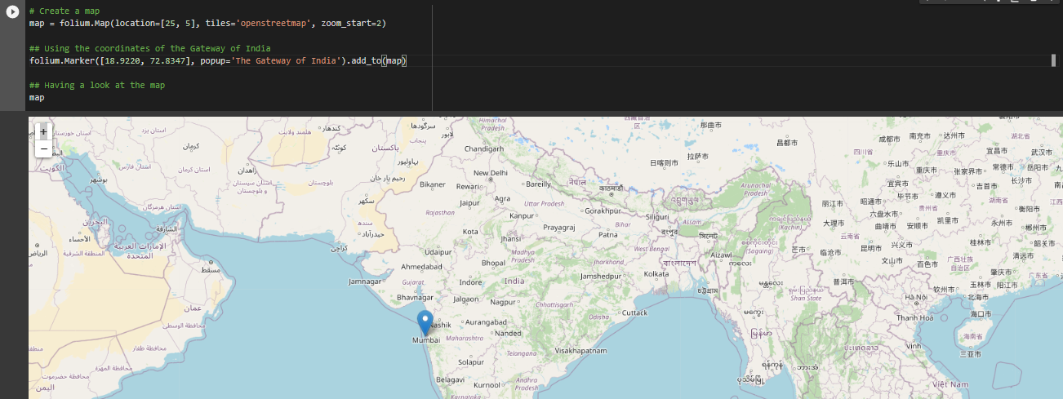

In the next couple of exercises, we will be looking into using the GeoPandas library and how to perform a few operations using this library. GeoPandas is a python library that expands the datatypes that pandas use to include geometric types for spatial operations. Shapely performs geometric operations. GeoPandas also uses matplotlib for charting and fiona for file access.

**Exercise 3:** Here we shall look into reading spatial data into the environment. Spatial data is stored as shapely data. mentioned, GeoPandas makes use of Shapely's geometric objects which means the geometries are stored in a column called as geometry (default column name) as shown below which are shapely Polygon objects.

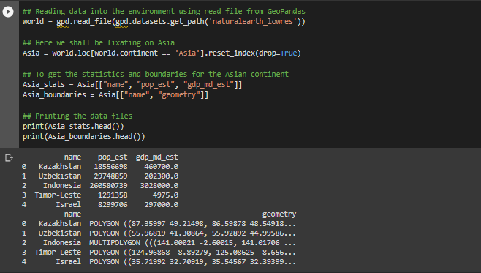

Once we have read the data into the environment using the read_file function from GeoPandas and performed a few transformations, we will go ahead and apply joins using a similar function as pandas.DataFrame.join() which is GeoPandas,DataFrame.join()

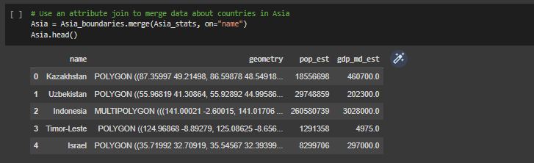

**Exercise 4:** In this next exercise we shall see how we can calculate the area of the polygon that have been listed under the countries in Asia. Here by using the function of area for a spatial data, we can have it calculated for us.

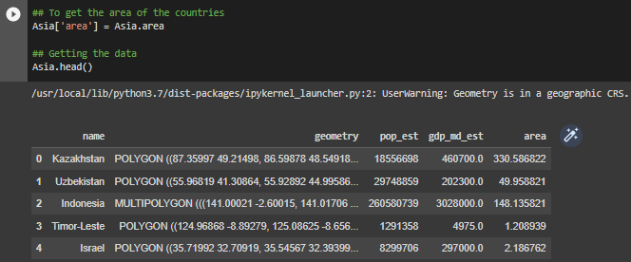

# The Adoption of Python in GIS

In the above section we looked into spatial analysis in python. Here we look into what makes Python the go-to language for spatial data and GIS. Python, in recent years, has seen widespread adoption across many domains. The rich and versatile libraries within python make it well-suited for any sort of project one would want to pick up. This can be majorly attributed to two reasons:

* It supports both structured programming and object orientation which makes it a **multi-paradigm** programming language
* As an interpreted language, python lends itself to **rapid prototyping and development cycles.**

GIScience (Geographic Information Science) has found a great receptive audience in python due to the emphasis on readability, support across platforms, and lower start-up costs. Python offers flexibility through various modes of development for geospatial programming. Lets look into the applications to understand how effective python for geospatial analysis is.

## Desktop and Interactive computational geospatial programming Applications of Python in GIS

* **ArcGIS** (post version 9.0) has included python as a core scripting language where the **ArcPy** package provides a platform for geoprocessing tools, functions, classes, and modules.
* **QGIS** (Open-source GIS package) offers a python console through its GUI providing an interactive shell to support experimentation with QGIS workshop allowing users to build workflows within existing sessions. Python has also been used to develop a processing framework which is a geoprocessing environment for running native or third-party algorithms within QGIS
* Python has also been used for developing standalone geospatial applications. These Python-based packages contain advanced geospatial capabilities inside a GUI. A Few examples are:
  + **GeoDaSpace**: Spatial regression analysis package
  + **CAST**: Crime Analytics in Space-Time
  + **STARS**: Space-Time Analysis of Regional Systems

We shall talk about the multiple spatial analysis python libraries use a table to talk about a few of the popular or commonly encountered packages from each layer in the stack.

|  |  |  |
| --- | --- | --- |
| **Layer** | **Package** | **Description** |
| Spatial Data Analysis | PySAL | To analyze clean spatial data in an interactive computational environment |
|  | GeoPandas | Pandas and shapely are combined to aid in working with geospatial vector data sets |
|  | GDAL/OGR | Allows working with both vector and raster data |
| Spatial Modelling | spint | SPatial INTeraction Modeling package for a collection of tools for studying spatial interaction data |
|  | mesa | A python framework for agent-based modeling |
|  | clusterpy | It is a library of spatially constrained clustering algorithms |
| geovisualization | cartopy | A package designed for geospatial data processing in order to produce maps and other geospatial data analysis |
|  | folium | For creating visualizations on interactive leaflet maps |
|  | datashader | A data rasterization pipeline for automating the process of creating meaningful visuals for big data |
| geoprocessing | shapely | A package for manipulation and analysis of planar geometric objects |
|  | rasterstats | A package for summarizing raster datasets based on the geometrics of vector |
|  | pyproj | A package for performing cartographic transformations and geodetic computations |

# The Basics

## Text

Adding text to a map that only describes geographic features on a map improves the visualization of geographic information immensely. The main types of text defined are labels, annotation and graphic test.

* **Label:** A piece of text that is automatically placed and consists of text string based on the feature attributes. Labels offer the easiest and fastest way to add descriptive text to the map. Example: Adding dynamic labelling for all the major cities in a country ****
* **Annotation:** These can be used to describe particular features or add general information on to the map that is being created. Annotations provide more flexibility in terms of the appearance and placement since we will have the ability to select individual text pieces and edit them ****
* **Graphic Text:** This is useful in adding information on and around the map that exists in page space. Use graphic text if you want to display text on your map page that does not change as you pan and zoom the map

## Vector

The most common type of data loaded into a GIS software program is vector data. It represents geographic data as points, lines, or polygons.

The vector data is split into three types which are:

* **Point data:** It is most frequently used to represent discrete data points and nonadjacent features. Since points have no dimensions, this dataset cannot be used to estimate either length or area. Additionally, point features are utilized to represent abstract points. For example, point locations can be utilized for city names and locations.
* **Line data**: Linear features are represented by line (or arc) data. Streets, pathways, and rivers are typical examples. Since line features only have one dimension, length is the only thing they can be utilized for. The line features consist of a starting and ending point
* **Polygons**: Areas like the boundary of a city (on a large-scale map), a lake, or a forest are represented by polygons. Since polygon features are two-dimensional, they can be used to calculate a geographic feature's area and perimeter.

## Raster

A raster, in its most basic form, is made up of a matrix of cells (or pixels) arranged into rows and columns (or a grid), each containing a value that represents some type of information. Raster includes digital aerial photos, satellite imagery, digital photos, and even scanned maps.

Data in raster formats represent real-world phenomena:

1. Thematic data, commonly referred to as discrete data, represents elements like soil or land use information.
2. Continuous data depict phenomena like temperature or height, or spectral data like satellite images and aerial photos.
3. Maps, drawings, and photographs of buildings are examples of pictures.

## Coordinate Reference System (CRS)

Without coordinate reference system (CRS) information that can be used by geospatial applications to display and manipulate the data correctly, a data structure cannot be considered geospatial. CRS information uses a mathematical model to link data to the Earth's surface. CRS then defines how the two-dimensional, projected map in your GIS relates to real places on the earth.

Components of CRS:

* **Datum:** A representation of the earth's form. It specifies the starting point (i.e., where is (0, 0)?) and has angular units (i.e., degrees) so the angles refer to a significant location on the planet.
* **Projection:** The angular measurements on the round earth are mathematically transformed to a flat surface. Typically, the units connected to a given projection are linear
* **Additional Parameters:** To establish the complete coordinate reference system, additional factors are often required. A definition of the map's center is a typical extra parameter.

## Map Projections

In cartography, one of the numerous techniques used to depict the three-dimensional surface of the globe or another spherical body on a two-dimensional plane is map projection (mapmaking). Usually, but not always, this process is a mathematical procedure (some methods are graphically based).

## Georeferencing

Georeferencing is defining the location of your raster data using map coordination and assigning the coordinate system of the map frame. Raster data can be viewed, queried, and analyzed with other geographic data using georeferencing.

There are generally four steps involved in Georeferencing process:

1. Adding the raster data that is to be aligned with the projected data
2. The georeferencing tab can be used to create control points that enable connection to the raster data to the known positions on the map
3. Reviewing the control points and the errors
4. Finally, saving the georeferencing results, when the alignment looks satisfactory

## Geocoding

Finding geographic coordinates for place names, street addresses, and codes is a process known as geocoding (e.g., zip codes). Preprocessing and standardizing the format of the data you will be geocoding are often steps in the data cleansing process that come before geocoding. *The resulting locations are output as geographic features with attributes, which can be used for mapping or spatial analysis.* There are many uses for geocoding, ranging from straightforward data analysis to customer and business management to distribution strategies. With geocoded addresses, you can visualize the locations of the addresses and spot patterns in the data.

# Python Geo-spatial libraries

## What can you put into geometry?

## Loading data

## CRS

## Visualization

## Reading in data

## Plotting the outbreak

# How Jupyter Notebook is used in GIS

Jupyter notebook is a powerful python tool which allows users to create and share documents containing codes, visualizations, explanatory test and equations. The few main reasons that we can attribute to the growing popularity of Jupyter Notebook could be as follows:

1. **Notebook**: The term notebook is quite applicable to the Jupyter Notebook as the tool allows us to write snippets of executable codes called as ‘cells’, comment down or note every procedure and also visualize the data during any step of your analysis
2. **Prototyping of Jupyter Notebook**: These notebooks are extremely useful in situations where we don't have a final process defined for ourselves. It gives us the flexibility in writing code and testing them into independent cells. This allows us to quickly test a code snippet without having to worry about any sequential workflow
3. **Visualizing Pandas DataFrame**: You can view these tables anywhere in your notebook when using Jupyter Notebook. This is really helpful since you can view your data's current state (and the impact of all the operations your code is making on it) as each stage of your logic executes.

Today, Jupyter notebooks have become the go to tool for GIS analysts who choose to do spatial analysis with python for multitude of tasks such as spatial data manipulation, spatial analysis, visualization, etc. Considering all the challenges that were a part of GIS software for doing geospatial analysis which includes

1. Data analysis and management of large spatial data
2. One size doesn't fit for all types of tools and analysis within a single application
3. Data format support issues, where not every application allows every format of data for input

The GIS community quickly realized its potential and adopted Python as a tool for GIS analysis, however Jupyter notebook provided the missing piece of becoming an easy-to-use tool that replaced the code editor as a working environment. Many geospatial Python packages are already available, including everything from geospatial data management to mapping capabilities inside a Jupyter Notebook.

To start utilizing the Jupyter Notebook application within a desktop GIS, the ArcGIS Notebook inside ArcGIS Pro comes with a default installation. QGIS users will need to install the IPython QGIS Console plugin. This gives access to the IPython Console inside of QGIS. The IPython Console allows users to execute commands and interact with data inside IPython interpreters which enables spatial data science python analysis.

# Conclusion

Here, with this article we have covered different aspects of Geospatial analysis. We started off by understanding what geospatial data is, which typically gives information about objects, events, and other features with a location on or near the earth’s surface. Now, with this data we also looked into how we can get started with working on it using different libraries such as GeoPy and GeoPandas. The base idea was to understand how to see how a spatial data looks like and how we can perform simple analysis using python spatial analysis libraries . The adoption of python shows how Python was accepted by many GIScientists as a go-to source for building desktop applications and standalone geospatial applications. The python ecosystem consists of numerous libraries that can be utilized for tasks across the spectrum to work with geospatial data. We looked into the basic concepts and terminologies of the spatial data which include text, vector and raster forms of data, what a Coordinate reference system is and how it is useful for Map projections, georeferencing and geocoding. Also, we went through to understand the pain points of the GIS and how Jupyter Notebook emerged as one of the leading options for having a single working environment for working with spatial analysis using python.

# Frequently Asked Questions (FAQs)

## Is Python or R better for spatial analysis?

The fact that Python being easy to learn as a language and the availability of numerous geospatial data analysis python libraries makes it very adaptable with users for Geospatial analysis. Major GIS platforms like ArcGIS and QGIS have adopted python as the principal scripting, toolmaking and analytical language. Python, according to experts, is also simpler to use than other high-level languages since it allows for a wide range of coding paradigms, including imperative, functional, procedural, and object-oriented ones.

R, in comparison to python, conducting spatial analysis with R can be just as simple. R programming language has seen an increase in the number of packages that are contributed towards GIS. R is also ideal for swiftly developing and visualizing vectorized data, which makes it simpler for people who don't want to put extra time in reading through documentation or creating hundreds of lines of codes to accomplish something simple.

It is crucial to realize that both of these programming languages for spatial analysis accomplish different things. Python is excellent for automation when performing tasks like network analysis or cost surface analysis for batches of data. But when working with large datasets, such as when conducting multiple regression analysis, R is considered indispensable. Hence it becomes tricky to chose between the both of them an wiser to use them for their own use-cases.

## How do you do geospatial analysis in Python?

The availability of great number of libraries from spatial analysis python packages, makes python a very powerful tool for spatial data analysis. It is simple as a process to load spatial data into python using libraries such as GeoPandas and perform spatial statistical analysis on the same dataset. We have various other libraries which enable the user to create visualizations suitable to any use-case at their disposable.

## What are the 5 concepts of spatial analysis?

## What is spatial analysis method?

## What is spatial analysis used for?

There are several uses for spatial analytic technology in both the public and business sectors. In addition to addressing global issues, it can be used to enhance local environments or communities. Time-lapsed spatial data analysis can be used to spot patterns and trends as well as anticipate future events quite accurately.

Spatial data analytics uses AI and ML applications to process enormous volumes of data with high levels of precision and efficiency.

# Author

**Anish Mahapatra**   
*Senior Data Scientist*   
LinkedIn: https://www.linkedin.com/in/anishmahapatra (LinkedIn)   
Email: anishmahapatra01@gmail.com